

**UNIVERSITY OF ASIA PACIFIC**

**Department of Computer Science & Engineering**

|  |
| --- |
| Dynamic Protocols RIP V2 |

**Course Code :** CSE 319

**Course Title :** Computer Networks Lab

**Submitted by: Submitted To: Name :** Sheikh Nafez Sadnan Md. Akhtaruzzamman Adnan **Reg. No. :** 20101106 Assistant Professor

**Roll No. :** 106 Department of CSE

**Section :** B (2) University of Asia Pacific

**Definition of RIP**

Routing Information Protocol (RIP) is a **dynamic distance-vector routing protocol**. Routers running the distance-vector protocol send all or a portion of their routing tables in routing-update messages to their neighbors. We can use RIP to configure the hosts as part of a RIP network. It uses hop count as a routing metric to find the best path between the source and the destination network. It is a distance-vector routing protocol that has an AD value of 120 and works on the Network layer of the OSI model. RIP uses port number 520.

**Features of RIP**

-Updates of the network are exchanged periodically.   
 -Updates (routing information) are always broadcast.   
 - Full routing tables are sent in updates.   
 - Routers always trust routing information received from neighbor routers. This is also known as *Routing on rumors*.

**RIP Versions**

There are three versions of routing information protocol – **RIP Version1**, **RIP Version2**, and **RIPng**.

**RIP Version-2**

The **Routing Information Protocol, version 2 (RIPv2)** is an enhanced version of RIP that includes support for important routing features such as class-less addressing and variable-length subnet masks. RIPv2 is a distance-vector protocol that has been in use for many years.

**Dynamic Routing protocols**

Dynamic routing is a networking technique that provides *optimal* data routing. Unlike static routing, dynamic routing enables routers to select paths according to real-time logical network layout changes.

Dynamic routing uses multiple algorithms and protocols. The most popular are Routing Information Protocol (RIP) and Open Shortest Path First (OSPF).

Dynamic routing protocols allow routers to share information about the network with other routers to allow them to select the best path to reach a destination.

**Advantages of Dynamic Routing**

* Allows the exchange of routing information whenever the network experiences a change in topology.
* Since the routes do not have to be configured manually, there is less administrative overhead.
* Less error-prone than static routing.
* Allows scalability since there is less administrative overhead involved.



How to implement **Dynamic protocols RIPv2**

**Step-1:** Open a project in Cisco Packet Tracer.Take router, switch, PC & laptop’s from the drop down menu. The amount of these equipment’s depends on the architecture of the project.

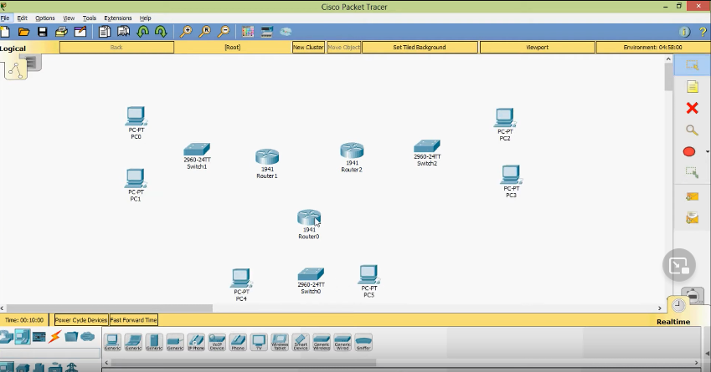

**Step-2:** Rename the equipment’s to avoid confusion.



**Step-3:** Add serial interface for the routers. Open a router, put off the device, select HWIC-2T and add that interface. Repeat process for all routers. Then turn on the module.

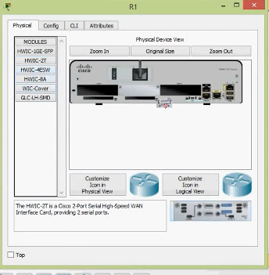

**Step-4:** Connect router with switch using g 0/0 and g 0/1& f 0/1, f 0/2 to connect PC & laptop’s with switch.

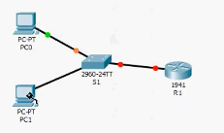

**Step-5:** Highlight it and note the network address. Repeat process for all networks. I’m using 192.168.1.0/24 for Network-1, 192.168.2.0/24 for Network-2, 192.168.3.0/24 for Network-3 & 192.168.4.0/24 for Network-4.

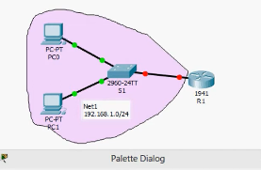

**Step-6:** Connect the routers using serial cable and highlight them.

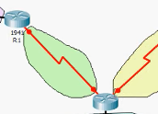

**Step-7:** Note down the network addresses beside the routers. I’m using 192.168.1.0/24 for Network-1, 192.168.2.0/24 for Network-2, 192.168.3.0/24 for Network-3 & 192.168.4.0/24 for Network-4.

**Step-8:** Set IP address for the PC & laptop’s. Select a PC/laptop, write down IP address, and default gateway for the PC/laptop. I’m using-

PC0: 192.168.1.10/24

PC1: 192.168.1.11/24

PC2: 192.168.1.12/24

LAPTOP6: 192.168.1.13/24

LAPTOP7: 192.168.1.14/24

PC3: 192.168.4.10/24

PC4: 192.168.4.11/24

PC5: 192.168.4.12/24

LAPTOP1: 192.168.4.13/24

LAPTOP0: 192.168.4.14/24

PC6: 192.168.2.10/24

PC7: 192.168.2.11/24

PC8: 192.168.2.12/24

LAPTOP5: 192.168.2.13/24

LAPTOP4: 192.168.2.14/24

PC9: 192.168.3.10/24

PC10: 192.168.3.11/24

PC11: 192.168.3.12/24

LAPTOP2: 192.168.3.13/24

LAPTOP3: 192.168.3.14/24

Default gateway’s- 192.168.1.1, 192.168.2.1, 192.168.3.1, 192.168.4.1

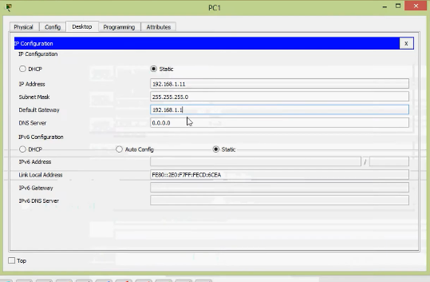

**Step-9:** Verify each local networks. It should become successful.

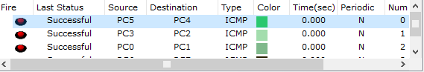

**Step-10:** Configure the default gateway of each network using the routers. Open terminal and write down the codes for the each dedicated routers, here I have 4 routers so I have to write 4 times-

*enable*

*configure terminal*

*hostname R1*

*interface gigabitEthernet 0/0*

*ip address 192.168.1.1 255.255.255.0*

*no shutdown*

*enable*

*configure terminal*

*hostname R2*

*interface gigabitEthernet 0/0*

*ip address 192.168.2.1 255.255.255.0*

*no shutdown*

*enable*

*configure terminal*

*hostname R3*

*interface gigabitEthernet 0/0*

*ip address 192.168.3.1 255.255.255.0*

*no shutdown*

*enable*

*configure terminal*

*hostname R4*

*interface gigabitEthernet 0/0*

*ip address 192.168.4.1 255.255.255.0*

*no shutdown*

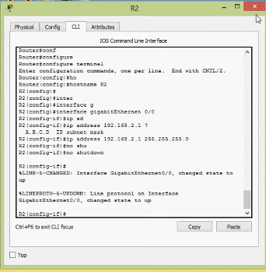

**Step-11:** Ping each PC & laptop’s to its default gateway. Commands for each section is-

*ping 192.168.1.1*

*ping 192.168.2.1*

*ping 192.168.3.1*

*ping 192.168.4.1*

Then we will see we are getting the reply.

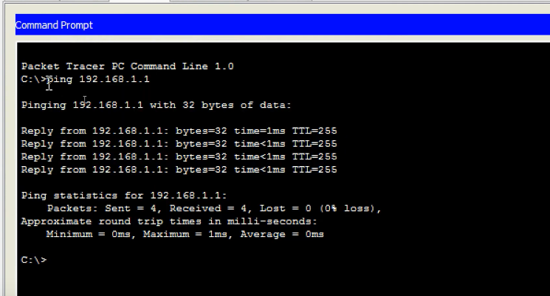

**Step-12**: Configure interface on each routers. Codes are-

*enable*

*configure terminal*

*interface serial 0/0/0*

*ip address 172.16.1.1 255.255.255.252*

*no shutdown*

*enable*

*configure terminal*

*interface serial 0/0/0*

*ip address 172.16.1.13 255.255.255.252*

*no shutdown*

*enable*

*configure terminal*

*interface serial 0/0/1*

*ip address 172.16.1.6 255.255.255.252*

*no shutdown*

*enable*

*configure terminal*

*interface serial 0/0/1*

*ip address 172.16.1.2 255.255.255.252*

*no shutdown*

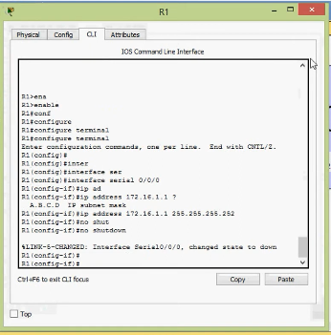

After operation in R1, between R1 and R3 the link is still down because we have to give no shut command to the other end.

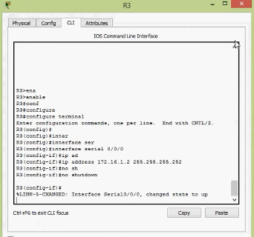

Then link between respective routers will be up. Repeat the process for all connection types.

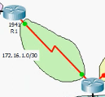

**Step-13:** Verify by pinging to R1 and R3 and vice versa. Commands are-

*ping 172.16.1.1*

*ping 172.16.1.13*

*ping 172.16.1.6*

*ping 172.16.1.2*

We will see the success rate is 100%

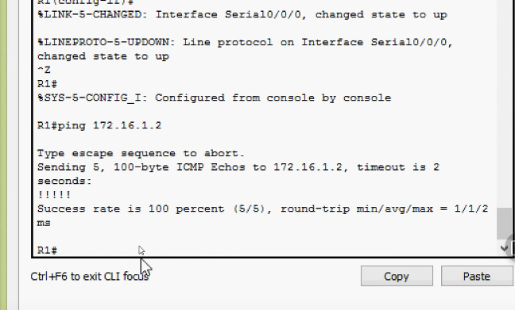

**Step-14:** Save the configuration on each routers. Command is-

*copy running-config startup-config*

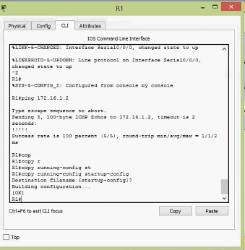

**Step-15:** Verify the routing table on each routers. Command is-

*show ip route*

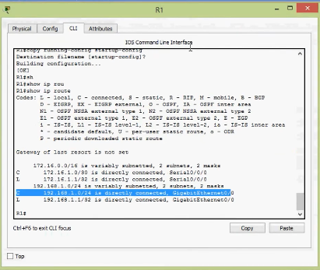

**Step-16:** Coming to the topology, give two network names. I’m using

172.16.1.0/30 for Network-5, 172.16.1.4/30 for Network-6, 172.16.1.8/30 for Network-7 & 172.16.1.12/30 for Network-8 here.

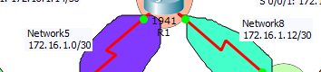

**Step-17:** Each router should be aware of each networks. Configure a dynamic routing protocol which is called RIP v2. The codes for the 4 routers are-

*enable*

*configure terminal*

*router rip*

*version 2*

*do sh ip rou con*

*network 172. 16.0.0*

*network 192.168.1.0*

*no auto-summary*

*enable*

*configure terminal*

*router rip*

*version 2*

*no auto-summary*

*do sh ip rou con*

*network 172. 16.0.0*

*network 192.168.2.0*

*enable*

*configure terminal*

*router rip*

*version 2*

*no auto-summary*

*do sh ip rou con*

*network 172. 16.0.0*

*network 192.168.3.0*

*enable*

*configure terminal*

*router rip*

*version 2*

*no auto-summary*

*do sh ip rou con*

*network 172. 16.0.0*

*network 192.168.4.0*

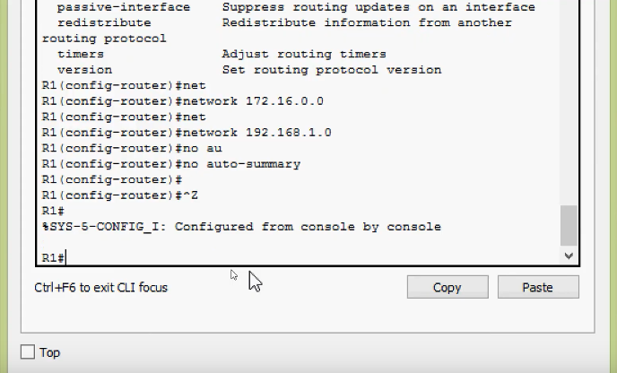

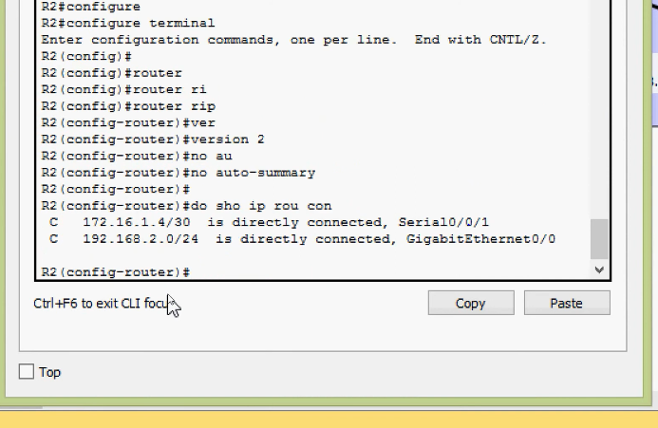

**Step-18:** Configure passive interface on each routers. Codes are-

*configure terminal*

*router rip*

*passive-interface gigabitEthernet 0/0*

also give the command-

*copy running-config startup-config*

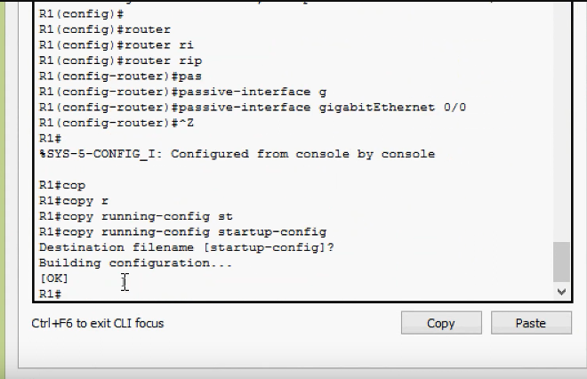

**Step-19:** Verify RIP configuration on each routers. Command is-

*show ip protocols*

or,

*show running-config*

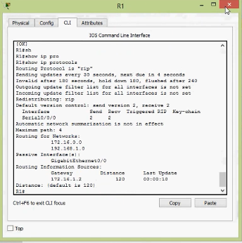

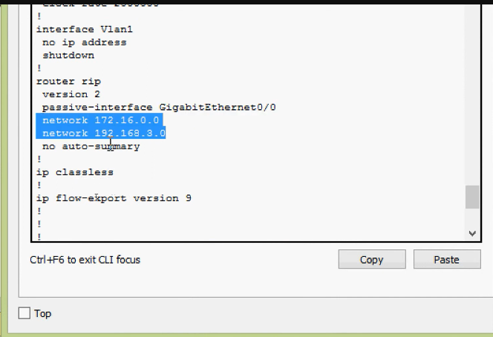

**Step-20***:* Verify the routing table of each routers. Command is-

*Show ip route*

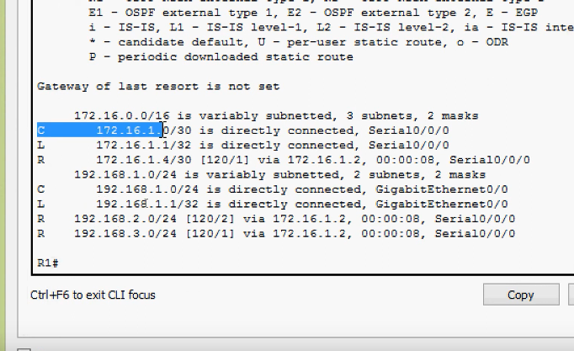

**Step-21:** Ping different networks. Open PC0/any other PC/laptop & the Command is-

*ping 192.168.2.10*

We will see we are getting the reply.

Similarly-

*ping 192.168.1.10*

*ping 192.168.3.10*

*ping 192.168.4.10*

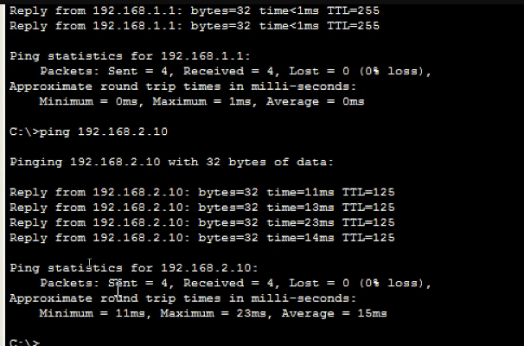

Now, each network is aware of every other networks-

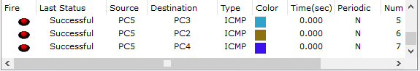

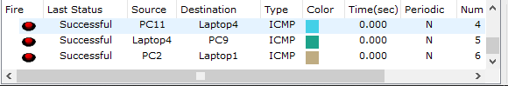

Final screenshot of the whole architecture-

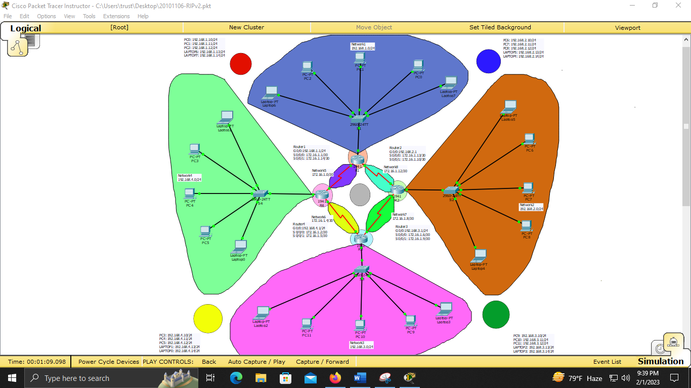

Detail view-

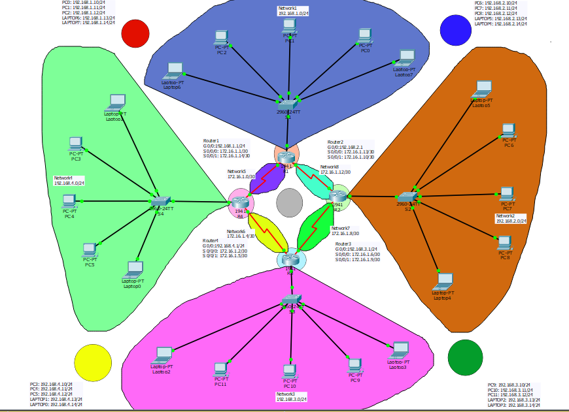

Part by part view-

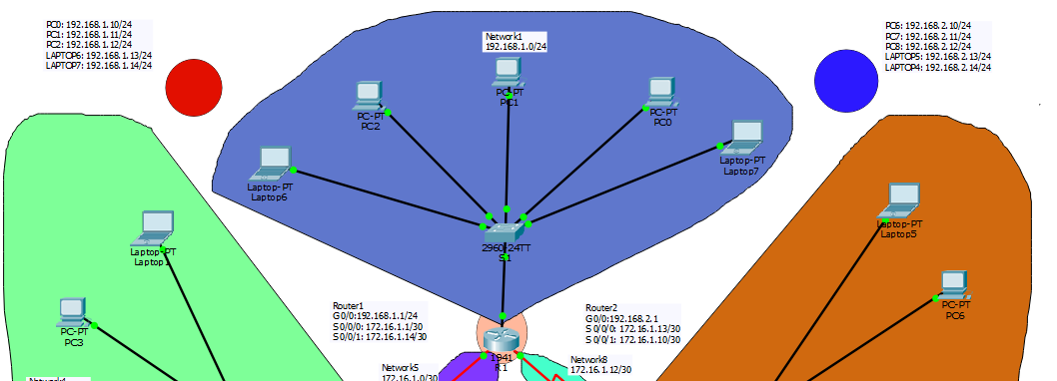

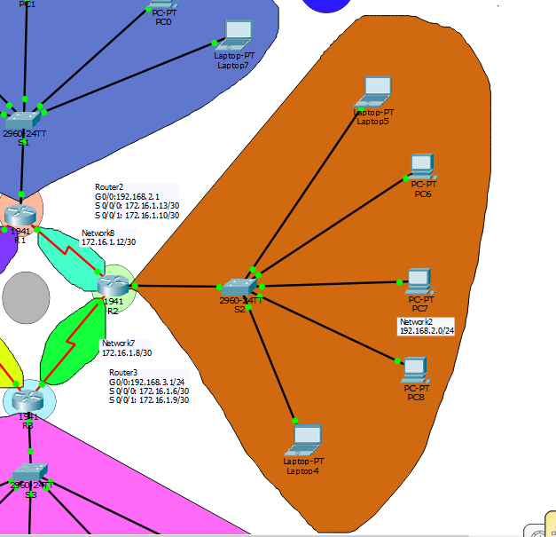

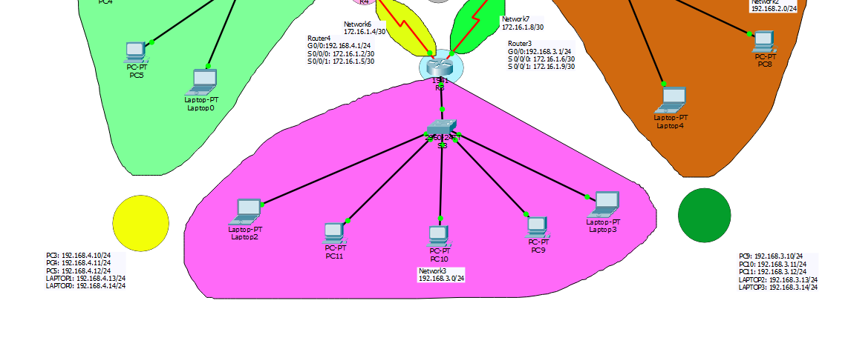

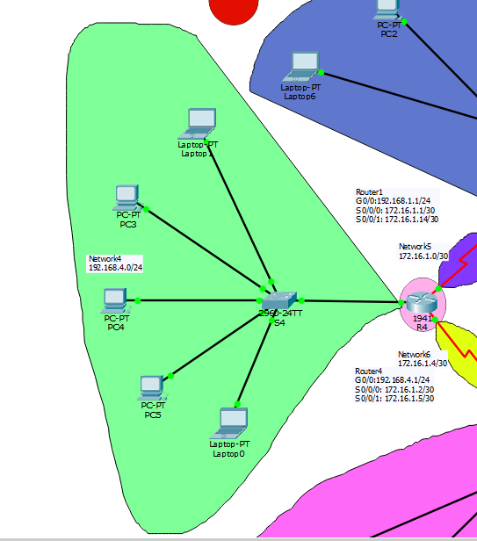

---------------------------THANK YOU FOR READING--------------------------